COP 2863 – Gehrig Project 5 Control Documentation William Ponton
AgentForm Controls:
# | Type | Name | Properties
1 | BoundField | FirstName | DataField="FirstName" HeaderText="FirstName"
2 | BoundField | LastName | DataField="LastName" HeaderText="LastName" SortExpression="LastName"
3 | BoundField | Agency | DataField="Agency" HeaderText="Agency"
4 | BoundField | Certifications | DataField="Certifications" HeaderText="Certifications"
5 | BoundField | Address | DataField="Address" HeaderText="Address"
6 | BoundField | Suite | DataField="Suite" HeaderText="Suite"
7 | BoundField | City | DataField="City" HeaderText="City"
8 | BoundField | State | DataField="State" HeaderText="State"
9 | BoundField | Zip | DataField="Zip" HeaderText="Zip" SortExpression="Zip"
10 | BoundField | Licenses | DataField="Licenses" HeaderText="Licenses"
11 | BoundField | Phone | DataField="Phone" HeaderText="Phone"
12 | GridView | gvAgents | ID="gvAgents" runat="server" AutoGenerateColumns="False" DataSourceID="odsAgentLocation"
13 | ObjectDataSource | odsAgentLocation | ID="odsAgentLocation" runat="server" SelectMethod="GetAllAgents" TypeName="PontonInsurance.Models.AgentDataAccessLayer" OldValuesParameterFormatString="original_{0}"

Control notes:
- gvAgents is a GridView which is Databound to the ObjectDataSource odsAgentLocation.
  - The GridView Pre Render is called on the page load and populates the GridView with data from the Locations Table in the Agents Database, located in the APP_DATA folder.
  - The user, not being an admin, is not allowed to Edit, Insert, or Delete any records.

AdminAgents Controls:
# | Type | Name | Properties
1 | Label | lblDisplay | ID="lblDisplay" runat="server" Text=""
2 | DetailsView | dvNewAgent | ID="dvNewAgent" runat="server" Height="500px" Width="400px" AutoGenerateRows="False" DataSourceID="odsAgentLocation" DefaultMode="Insert" OnItemInserted="dvNewAgent_ItemInserted" CssClass="table table-bordered table-condensed"
3 | BoundField | FirstName | DataField="FirstName" HeaderText="FirstName"
4 | BoundField | LastName | DataField="LastName" HeaderText="LastName" SortExpression="LastName"
5 | BoundField | Agency | DataField="Agency" HeaderText="Agency"
6 | BoundField | Certifications | DataField="Certifications" HeaderText="Certifications"
7 | BoundField | Address | DataField="Address" HeaderText="Address"
8 | BoundField | Suite | DataField="Suite" HeaderText="Suite"
9 | BoundField | City | DataField="City" HeaderText="City"
10 | BoundField | State | DataField="State" HeaderText="State"
11 | BoundField | Zip | DataField="Zip" HeaderText="Zip" SortExpression="Zip"
12 | BoundField | Licenses | DataField="Licenses" HeaderText="Licenses"
13 | BoundField | Phone | DataField="Phone" HeaderText="Phone"
14 | GridView | gvAgentsEdit | ID="gvAgentsEdit" runat="server" AutoGenerateColumns="False" AllowSorting="True"
 |  |  | DataSourceID="odsAgentLocation"
 |  |  | OnPreRender="gvAgents_PreRender"
 |  |  | OnDeleted="odsAgentLocation_RowsDeleted"
 |  |  | OnUpdated="odsAgentLocation_RowsUpdated"
15 | ObjectDataSource | odsAgentLocation | ID="odsAgentLocation" runat="server"
 |  |  | DataObjectTypeName="PontonInsurance.Models.AgentLocation"
 |  |  | DeleteMethod="DeleteAgent"
 |  |  | InsertMethod="InsertAgent"
 |  |  | OldValuesParameterFormatString="original_{0}"
 |  |  | SelectMethod="GetAllAgents"
 |  |  | UpdateMethod="UpdateAgent"
 |  |  | TypeName="PontonInsurance.Models.AgentDataAccessLayer"
 |  |  | ConflictDetection="CompareAllValues"
 |  |  | OnDeleted="odsAgentLocation_GetAffectedRows"
 |  |  | OnUpdated="odsAgentLocation_GetAffectedRows"

Control Notes:
- To see this page, the user must login as an Admin, using the “admin” username and the “Password#123” password.
- dvNewAgent is a DetailsView that is Databound to ObjectDataSource odsAgentLocation.
  - The user is allowed to Insert a New Agent record from this Control.
- odsAgentLocation contains Methods for Select, Edit, Update, and Delete which are allowed because the user is an admin.
- gvAgentsEdit is a GridView that is Databoung to ObjectDataSource odsAgentLocation.
  - The user is allowed to Edit and Delete records in this Control.

Source Code

AgentDataAccessLayer Class: AgentDataAccessLayer.cs
/*
* Filename: AgentDataAccessLayer
* Date: 3.20.18
* Author: William Ponton
* Description: Specification for the AgentDataAccessLayer Class
*/
using System;
using System.Collections.Generic;
using System.Linq;
using System.Web;
using System.Configuration;
using System.Data;
using System.Data.SqlClient;
using System.ComponentModel;

namespace PontonInsurance.Models
{

/// <summary>
/// AgentDataAccessLayer
/// The DataAccessLayer Specifications and SQL Access Methods
/// </summary>
#region AgentDataAccessLayer
[DataObject(true)]
public class AgentDataAccessLayer
{
/// <summary>
/// Open Constructor
/// </summary>
AgentDataAccessLayer()
{

}
/// <summary>
/// DataObjectMethod GetAllAgents
/// Loads all records from the database into the gvAgents GridView Control.
/// </summary>
/// <returns>agentList</returns>
#region GetAllAgents
[DataObjectMethod(DataObjectMethodType.Select)]
public static List<AgentLocation> GetAllAgents()
{
List<AgentLocation> agentList = new List<AgentLocation>();
string cs = ConfigurationManager.ConnectionStrings["AgentAdmin"].ConnectionString;
using (SqlConnection con = new SqlConnection(cs))
{
SqlCommand cmd = new SqlCommand("SELECT * FROM Locations", con);
con.Open();
SqlDataReader rdr = cmd.ExecuteReader();
while (rdr.Read())
{
AgentLocation myAgent = new AgentLocation();
myAgent.Id = Convert.ToInt32(rdr["Id"]);
myAgent.FirstName = rdr["FirstName"].ToString();
myAgent.LastName = rdr["LastName"].ToString();
myAgent.Agency = rdr["Agency"].ToString();
myAgent.Certifications = rdr["Certifications"].ToString();
myAgent.Address = rdr["Address"].ToString();
myAgent.Suite = rdr["Suite"].ToString();
myAgent.City = rdr["City"].ToString();
myAgent.State = rdr["State"].ToString();
myAgent.Zip = rdr["Zip"].ToString();
myAgent.Licenses = rdr["Licenses"].ToString();
myAgent.Phone = rdr["Phone"].ToString();
agentList.Add(myAgent);
}
}
return agentList;
}
#endregion

/// <summary>
/// GetConnectionString
/// </summary>
/// <returns>AgentAdmin Connection String</returns>
#region GetConnectionString
public static string GetConnectionString()
{
return ConfigurationManager.ConnectionStrings
["AgentAdmin"].ConnectionString;
}
#endregion

/// <summary>
/// DataObjectMethod InsertAgent
/// Inserts data from the client into the database.
/// </summary>
/// <param name="myAgent">myAgent</param>
#region InsertAgent
[DataObjectMethod(DataObjectMethodType.Insert)]
public static void InsertAgent(AgentLocation myAgent)
{
string sql = "INSERT INTO Locations "
+ "(Id, FirstName, LastName, Agency, Certifications, Address, Suite, City, State, Zip, Licenses, Phone) "
+ "VALUES (@Id, @FirstName, @LastName, @Agency, @Certifications, @Address, @Suite, @City, @State, @Zip, @Licenses, @Phone)";
using (SqlConnection con = new SqlConnection(GetConnectionString()))
{
using (SqlCommand cmd = new SqlCommand(sql, con))
{
cmd.Parameters.AddWithValue("Id", myAgent.Id);
cmd.Parameters.AddWithValue("FirstName", myAgent.FirstName);
cmd.Parameters.AddWithValue("LastName", myAgent.LastName);
cmd.Parameters.AddWithValue("Agency", myAgent.Agency);
cmd.Parameters.AddWithValue("Certifications", myAgent.Certifications);
cmd.Parameters.AddWithValue("Address", myAgent.Address);
cmd.Parameters.AddWithValue("Suite", myAgent.Suite);
cmd.Parameters.AddWithValue("City", myAgent.City);
cmd.Parameters.AddWithValue("State", myAgent.State);
cmd.Parameters.AddWithValue("Zip", myAgent.Zip);
cmd.Parameters.AddWithValue("Licenses", myAgent.Licenses);
cmd.Parameters.AddWithValue("Phone", myAgent.Phone);

con.Open();
cmd.ExecuteNonQuery();
}
}
}
#endregion

/// <summary>
/// DataObjectMethod DeleteAgent
/// Removes an Agent record from the database.
/// </summary>
/// <param name="myAgent"></param>
/// <returns>deleteCount</returns>
#region DeleteAgent
[DataObjectMethod(DataObjectMethodType.Delete)]
public static int DeleteAgent(AgentLocation myAgent)
{
int deleteCount = 0;
string sql = "DELETE FROM Locations "
+ "WHERE Id = @Id "
+ "AND FirstName = @FirstName "
+ "AND LastName = @LastName "
+ "AND Agency = @Agency "
+ "AND Certifications = @Certifications "
+ "AND Address = @Address "
+ "AND Suite = @Suite "
+ "AND City = @City "
+ "AND State = @State "
+ "AND Zip = @Zip "
+ "AND Licenses = @Licenses "
+ "AND Phone = @Phone";
using (SqlConnection con = new SqlConnection(GetConnectionString()))
{
using (SqlCommand cmd = new SqlCommand(sql, con))
{
cmd.Parameters.AddWithValue("Id", myAgent.Id);
cmd.Parameters.AddWithValue("FirstName", myAgent.FirstName);
cmd.Parameters.AddWithValue("LastName", myAgent.LastName);
cmd.Parameters.AddWithValue("Agency", myAgent.Agency);
cmd.Parameters.AddWithValue("Certifications", myAgent.Certifications);
cmd.Parameters.AddWithValue("Address", myAgent.Address);
cmd.Parameters.AddWithValue("Suite", myAgent.Suite);
cmd.Parameters.AddWithValue("City", myAgent.City);
cmd.Parameters.AddWithValue("State", myAgent.State);
cmd.Parameters.AddWithValue("Zip", myAgent.Zip);
cmd.Parameters.AddWithValue("Licenses", myAgent.Licenses);
cmd.Parameters.AddWithValue("Phone", myAgent.Phone);

con.Open();
deleteCount = cmd.ExecuteNonQuery();
}

}
return deleteCount;
}
#endregion

/// <summary>
/// DataObjectMethod UpdateAgent
/// Updates an existing record in the database.
/// </summary>
/// <param name="original_Agent"></param>
/// <param name="myAgent"></param>
/// <returns>updateCount</returns>
#region UpdateAgent
[DataObjectMethod(DataObjectMethodType.Update)]
public static int UpdateAgent(AgentLocation original_Agent, AgentLocation myAgent)
{
int updateCount = 0;
string sql = "UPDATE Locations "
+ "SET Id = @Id, "
+ "FirstName = @FirstName, "
+ "LastName = @LastName, "
+ "Agency = @Agency, "
+ "Certifications = @Certifications, "
+ "Address = @Address, "
+ "Suite = @Suite, "
+ "City = @City, "
+ "State = @State, "
+ "Zip = @Zip, "
+ "Licenses = @Licenses, "
+ "Phone = @Phone "
+ "WHERE Id = @original_Id "
+ "AND FirstName = @original_FirstName "
+ "AND LastName = @original_LastName "
+ "AND Agency = @original_Agency "
+ "AND Certifications = @original_Certifications "
+ "AND Address = @original_Address "
+ "AND Suite = @original_Suite "
+ "AND City = @original_City "
+ "AND State = @original_State "
+ "AND Zip = @original_Zip "
+ "AND Licenses = @original_Licenses "
+ "AND Phone = @original_Phone";
using (SqlConnection con = new SqlConnection(GetConnectionString()))
{
using (SqlCommand cmd = new SqlCommand(sql, con))
{
cmd.Parameters.AddWithValue("FirstName", myAgent.FirstName);
cmd.Parameters.AddWithValue("LastName", myAgent.LastName);
cmd.Parameters.AddWithValue("Agency", myAgent.Agency);
cmd.Parameters.AddWithValue("Certifications", myAgent.Certifications);
cmd.Parameters.AddWithValue("Address", myAgent.Address);
cmd.Parameters.AddWithValue("Suite", myAgent.Suite);
cmd.Parameters.AddWithValue("City", myAgent.City);
cmd.Parameters.AddWithValue("State", myAgent.State);
cmd.Parameters.AddWithValue("Zip", myAgent.Zip);
cmd.Parameters.AddWithValue("Licenses", myAgent.Licenses);
cmd.Parameters.AddWithValue("Phone", myAgent.Phone);

cmd.Parameters.AddWithValue("original_Id", original_Agent.Id);
cmd.Parameters.AddWithValue("original_FirstName", original_Agent.FirstName);
cmd.Parameters.AddWithValue("original_LastName", original_Agent.LastName);
cmd.Parameters.AddWithValue("original_Agency", original_Agent.Agency);
cmd.Parameters.AddWithValue("original_Certifications", original_Agent.Certifications);
cmd.Parameters.AddWithValue("original_Address", original_Agent.Address);
cmd.Parameters.AddWithValue("original_Suite", original_Agent.Suite);
cmd.Parameters.AddWithValue("original_City", original_Agent.City);
cmd.Parameters.AddWithValue("original_State", original_Agent.State);
cmd.Parameters.AddWithValue("original_Zip", original_Agent.Zip);
cmd.Parameters.AddWithValue("original_Licenses", original_Agent.Licenses);
cmd.Parameters.AddWithValue("original_Phone", original_Agent.Phone);

con.Open();
updateCount = cmd.ExecuteNonQuery();
}
}
return updateCount;
}
#endregion
}
#endregion
}

AgentForm.aspx
<%@ Page Title="" Language="C#" MasterPageFile="~/Site.Master" AutoEventWireup="true" CodeBehind="AgentForm.aspx.cs" Inherits="PontonInsurance.AgentForm" %>

<asp:Content ID="Content1" ContentPlaceHolderID="MainContent" runat="server">
<!--
Filename: AgentForm.aspx
Date: 3.12.18
Author: William Ponton
Description: aspx file for the AgentForm page.
-->

<div class="container">

<!-- Welcome -->
<div class="row">
<div class="col-md-offset-2 col-md-8">
<h1>Ponton Insurance Group Registered Agents</h1>
</div>
</div>

<!-- Break Row -->
<div class="row">
<br />
</div>

<!-- Subheading -->
<div class="row">
<div class="col-md-offset-4 col-md-8">
<h3>Find a representative near you.</h3>
</div>
</div>

<!-- Break Row -->
<div class="row">
<br />
</div>

<!-- Agent Data -->
<div class="table table-bordered table-striped table-condensed" onprerender="gvAgents_PreRender">
<asp:GridView ID="gvAgents" runat="server" AutoGenerateColumns="False" DataSourceID="odsAgentLocation">
<Columns>
<asp:BoundField DataField="FirstName" HeaderText="FirstName" SortExpression="FirstName" />
<asp:BoundField DataField="LastName" HeaderText="LastName" SortExpression="LastName" />
<asp:BoundField DataField="Agency" HeaderText="Agency" SortExpression="Agency" />
<asp:BoundField DataField="Certifications" HeaderText="Certifications" SortExpression="Certifications" />
<asp:BoundField DataField="Address" HeaderText="Address" SortExpression="Address" />
<asp:BoundField DataField="Suite" HeaderText="Suite" SortExpression="Suite" />
<asp:BoundField DataField="City" HeaderText="City" SortExpression="City" />
<asp:BoundField DataField="State" HeaderText="State" SortExpression="State" />
<asp:BoundField DataField="Zip" HeaderText="Zip" SortExpression="Zip" />
<asp:BoundField DataField="Licenses" HeaderText="Licenses" SortExpression="Licenses" />
<asp:BoundField DataField="Phone" HeaderText="Phone" SortExpression="Phone" />
</Columns>
</asp:GridView>
<asp:ObjectDataSource ID="odsAgentLocation" runat="server" SelectMethod="GetAllAgents" TypeName="PontonInsurance.Models.AgentDataAccessLayer" OldValuesParameterFormatString="original_{0}"></asp:ObjectDataSource>
</div>

<!-- Break Row -->
<div class="row">
<br />
</div>

</div>
<!-- End container -->
</asp:Content>

AgentForm.aspx.cs

/*
* Filename: AgentForm.aspx
* Date: 3.12.18
* Author: William Ponton
* Description: AgentForm displays data from a database in a gridview format.
*/
using System;
using System.Collections.Generic;
using System.Linq;
using System.Web;
using System.Web.UI;
using System.Web.UI.WebControls;
using System.Data;
using System.Data.SqlClient;
using System.Configuration;

namespace PontonInsurance
{
public partial class AgentForm : System.Web.UI.Page
{
/// <summary>
/// Page_Load
/// Events that occur when the page is loaded.
/// </summary>
/// <param name="sender">Control Initiating Event</param>
/// <param name="e">Event Argument</param>
protected void Page_Load(object sender, EventArgs e)
{

}

/// <summary>
/// gvAgents PreRender Method
/// </summary>
/// <param name="sender">Control Initiating Event</param>
/// <param name="e">Event Argument</param>
protected void gvAgents_PreRender(object sender, EventArgs e)
{
if (gvAgents.HeaderRow != null)
{
gvAgents.HeaderRow.TableSection = TableRowSection.TableHeader;
}
}
}
}

AdminAgents.aspx

<%@ Page Title="AdminAgents" Language="C#" MasterPageFile="~/Site.Master" AutoEventWireup="true" CodeBehind="AdminAgents.aspx.cs" Inherits="PontonInsurance.AdminAgents" %>

<asp:Content ID="Content1" ContentPlaceHolderID="MainContent" runat="server">
<!--
Filename: AgentForm.aspx
Date: 3.21.18
Author: William Ponton
Description: aspx file for the AgentForm page.
-->

<div class="container">

<!-- Welcome -->
<div class="row">
<div class="col-md-offset-3 col-md-8">
<h1>Ponton Insurance Registered Agents</h1>
</div>
</div>

<div class="row">
<br />
</div>

<!-- Subheading -->
<div class="row">
<div class="col-md-offset-4 col-md-8">
<h3>Administrative Maintenance Page</h3>
</div>
</div>

<!-- Break Row -->
<div class="row">
<br />
</div>

<!-- Break Row -->
<div class="row">
<br />
</div>

<!-- Display -->
<div class="row">
<div class="col-md-offset-4 col-md-4">
<div class="label">
<asp:Label ID="lblDisplay" runat="server" Text=""></asp:Label>
</div>
</div>
</div>

<!-- Agent Insert DetailsView -->
<div class="row">
<div class="col-md-6">
<p>To create a new Agent, enter the Agent Info and click Insert.</p>
</div>
<asp:DetailsView ID="dvNewAgent" runat="server" Height="500px" Width="400px"
AutoGenerateRows="False" DataSourceID="odsAgentLocation"
DefaultMode="Insert"
OnItemInserted="dvNewAgent_ItemInserted"
CssClass="table table-bordered table-condensed" >
<Fields>
<asp:BoundField DataField="FirstName" HeaderText="FirstName" />
<asp:BoundField DataField="LastName" HeaderText="LastName" SortExpression="LastName" />
<asp:BoundField DataField="Agency" HeaderText="Agency" />
<asp:BoundField DataField="Certifications" HeaderText="Certifications" />
<asp:BoundField DataField="Address" HeaderText="Address" />
<asp:BoundField DataField="Suite" HeaderText="Suite" />
<asp:BoundField DataField="City" HeaderText="City" />
<asp:BoundField DataField="State" HeaderText="State" />
<asp:BoundField DataField="Zip" HeaderText="Zip" SortExpression="Zip" />
<asp:BoundField DataField="Licenses" HeaderText="Licenses" />
<asp:BoundField DataField="Phone" HeaderText="Phone" />
<asp:CommandField ShowInsertButton="True" />
</Fields>
<RowStyle CssClass="rowStyle" />
<CommandRowStyle CssClass="commandRowStyle" />
</asp:DetailsView>
</div>

<!-- Agent Data GridView -->
<div class="table table-bordered table-striped table-condensed" onprerender="gvAgents_PreRender">
<asp:GridView ID="gvAgentsEdit" runat="server" AutoGenerateColumns="False" AllowSorting="True"
DataSourceID="odsAgentLocation"
OnPreRender="gvAgents_PreRender"
OnDeleted="odsAgentLocation_RowsDeleted"
OnUpdated="odsAgentLocation_RowsUpdated">
<Columns>
<asp:BoundField DataField="FirstName" HeaderText="FirstName" />
<asp:BoundField DataField="LastName" HeaderText="LastName" SortExpression="LastName" />
<asp:BoundField DataField="Agency" HeaderText="Agency" />
<asp:BoundField DataField="Certifications" HeaderText="Certifications" />
<asp:BoundField DataField="Address" HeaderText="Address" />
<asp:BoundField DataField="Suite" HeaderText="Suite" />
<asp:BoundField DataField="City" HeaderText="City" />
<asp:BoundField DataField="State" HeaderText="State" />
<asp:BoundField DataField="Zip" HeaderText="Zip" SortExpression="Zip" />
<asp:BoundField DataField="Licenses" HeaderText="Licenses" />
<asp:BoundField DataField="Phone" HeaderText="Phone" />
<asp:CommandField ShowEditButton="True" />
<asp:CommandField ShowDeleteButton="True" />

</Columns>
</asp:GridView>

<!-- Object Data Source odsAgentLocation -->
<asp:ObjectDataSource ID="odsAgentLocation" runat="server"
DataObjectTypeName="PontonInsurance.Models.AgentLocation"
DeleteMethod="DeleteAgent"
InsertMethod="InsertAgent"
OldValuesParameterFormatString="original_{0}"
SelectMethod="GetAllAgents"
UpdateMethod="UpdateAgent"
TypeName="PontonInsurance.Models.AgentDataAccessLayer"
ConflictDetection="CompareAllValues"
OnDeleted="odsAgentLocation_GetAffectedRows"
OnUpdated="odsAgentLocation_GetAffectedRows">

<UpdateParameters>
<asp:Parameter Name="original_Agent" Type="Object" />
<asp:Parameter Name="myAgent" Type="Object" />
</UpdateParameters>

</asp:ObjectDataSource>
<br />
</div>

<!-- Break Row -->
<div class="row">
<br />
</div>
<!-- End container -->
</div>
</asp:Content>

AdminAgents.aspx.cs
/*
* Filename: AdminAgents.aspx.cs
* Date: 3.21.18
* Author: William Ponton
* Description: Agent Data with Admin rights to edit, delte, and add new.
*/
using System;
using System.Collections.Generic;
using System.Linq;
using System.Web;
using System.Web.UI;
using System.Web.UI.WebControls;
using System.Data;
using System.Data.SqlClient;
using System.Configuration;
using PontonInsurance.Models;

namespace PontonInsurance
{
/// <summary>
/// AdminAgents Form
/// </summary>
public partial class AdminAgents : System.Web.UI.Page
{
/// <summary>
/// Page_Load
/// </summary>
/// <param name="sender">Control Initiating Event</param>
/// <param name="e">Event Argument</param>
protected void Page_Load(object sender, EventArgs e)
{

}

/// <summary>
/// gvAgents PreRender Method
/// </summary>
/// <param name="sender">Control Initiating Event</param>
/// <param name="e">Event Argument</param>
protected void gvAgents_PreRender(object sender, EventArgs e)
{
if (gvAgentsEdit.HeaderRow != null)
{
gvAgentsEdit.HeaderRow.TableSection = TableRowSection.TableHeader;
}
}

/// <summary>
/// GetAffectedRows
/// </summary>
/// <param name="sender">Control Initiating Event</param>
/// <param name="e">Event Argument</param>
protected void odsAgentLocation_GetAffectedRows(object sender,
ObjectDataSourceStatusEventArgs e)
{
e.AffectedRows = Convert.ToInt32(e.ReturnValue);
}

/// <summary>
/// RowsUpdated
/// </summary>
/// <param name="sender">Control Initiating Event</param>
/// <param name="e">Event Argument</param>
protected void gvAgentsEdit_RowsUpdated(object sender, GridViewUpdatedEventArgs e)
{
if (e.Exception != null)
{
lblDisplay.Text = e.Exception.ToString();
e.ExceptionHandled = true;
e.KeepInEditMode = true;
}
else if (e.AffectedRows == 0)
{
lblDisplay.Text = ConcurrencyErrorMessage();
}
}

/// <summary>
/// ItemInserted
/// </summary>
/// <param name="sender">Control Initiating Event</param>
/// <param name="e">Event Argument</param>
protected void dvNewAgent_ItemInserted(object sender,
DetailsViewInsertedEventArgs e)
{

if (e.Exception != null)
{
lblDisplay.Text = "Error! " + DatabaseErrorMessage(e.Exception) + " Insertion error!";
e.ExceptionHandled = true;
}
}

/// <summary>
/// RowsDeleted
/// </summary>
/// <param name="sender">Control Initiating Event</param>
/// <param name="e">Event Argument</param>
protected void gvAgentsEdit_RowsDeleted(object sender, GridViewDeletedEventArgs e)
{
if (e.Exception != null)
{
lblDisplay.Text = "Error! " + DatabaseErrorMessage(e.Exception) + " Deletion error!";
e.ExceptionHandled = true;
}
else if (e.AffectedRows == 0)
{
lblDisplay.Text = ConcurrencyErrorMessage();
}
}

/// <summary>
/// DatabaseErrorMessage
/// </summary>
/// <param name="ex">Exception ex</param>
/// <returns>Message</returns>
private string DatabaseErrorMessage(Exception ex)
{
string msg = $"<b>A database error has occured:</b> {ex.Message}";
if (ex.InnerException != null)
{
msg += $"<br />Message: {ex.InnerException.Message}";
}
return msg;
}

/// <summary>
/// ConcurrencyErrorMessage
/// </summary>
/// <returns>Message</returns>
private string ConcurrencyErrorMessage()
{
string message;
message = "Another user may have updated this record already. Please try again.";
return message;
}

/// <summary>
/// odsAgentLocation_Deleted
/// </summary>
/// <param name="sender">Control Initiating Event</param>
/// <param name="e">Event Argument</param>
protected void odsAgentLocation_Deleted(object sender, ObjectDataSourceStatusEventArgs e)
{
if (e.Exception != null)
{
lblDisplay.Text = DatabaseErrorMessage(e.Exception);
e.ExceptionHandled = true;
}
else if (e.AffectedRows == 0)
{
lblDisplay.Text = "Error! " + ConcurrencyErrorMessage() +" Concurrency Error!";
}
}
}
}

Testing

Login 1:
The Controls to Login are Visible only after pressing the “Agents” button.
Validation Controls are displayed for empty TextBoxes on the Home Page, in error.


Login 2:

UserName: “user”
Password: “Password#456”
Result: User is Redirected to the AgentForm, which is not able to be updated, only viewed.
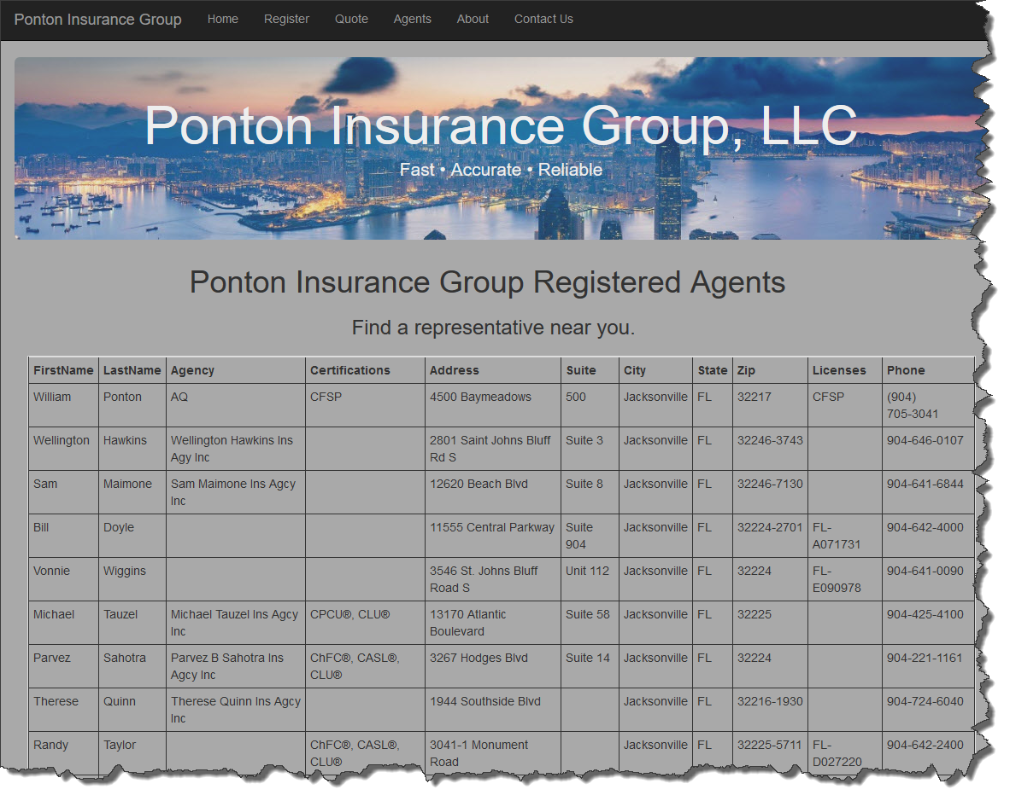

Login 3:

UserName: “admin”
Password: “Password#123
Result: User is Redirected to the AdminAgents, in the user can Update, Insert, and Delete records.



AgentForm:

A GridView is used to display data from the ObjectDataSource. The user is not able to edit the data because they have not logged in as an administrator.
A DetailsView allows the user to insert a new record into the database.
- DetailsView dvNewAgent:


- GridView gvAgentsEdit, which is configured to let the user sort by LastName and Zipcode:
The user is also able to edit or delete a record.
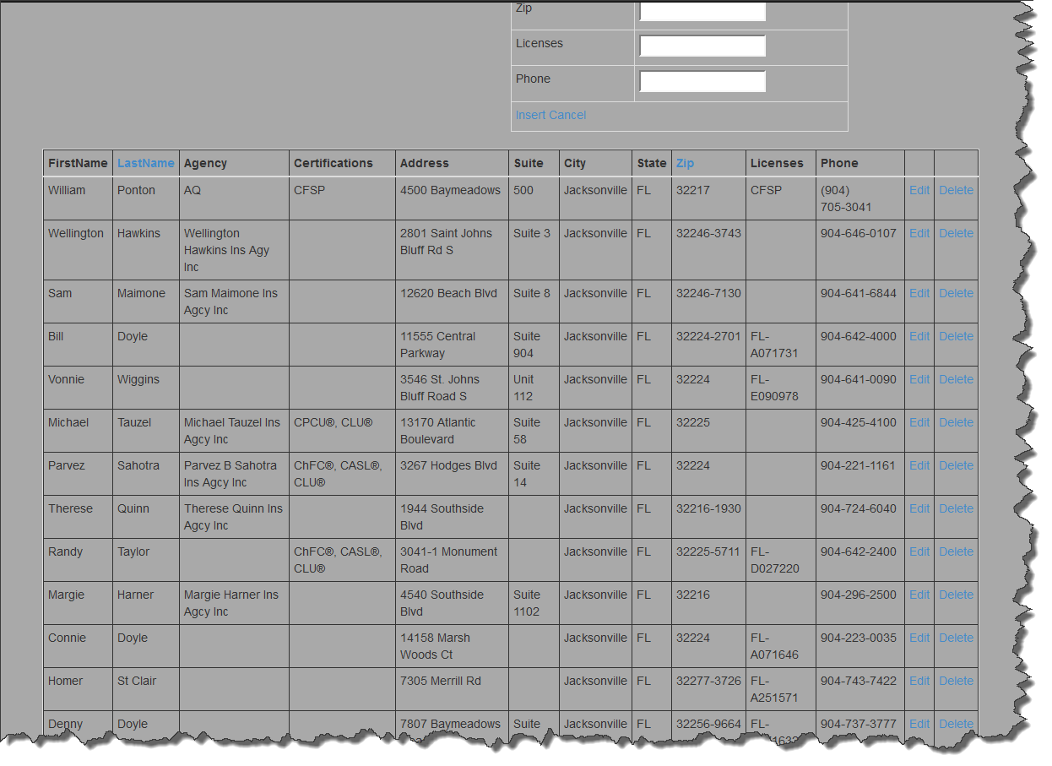

- A new Agent is entered into the system:
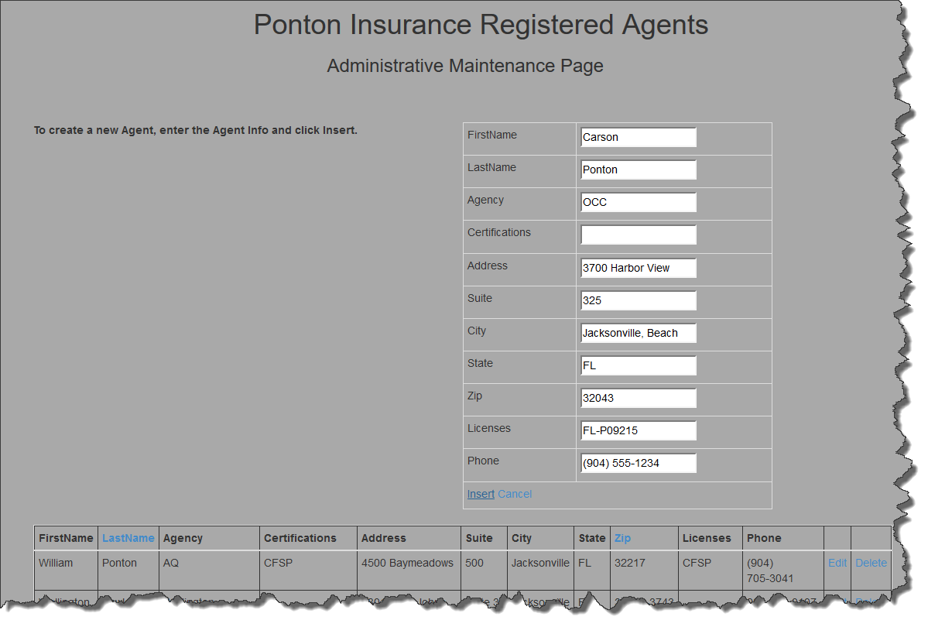

- I am crashing when trying to create a new record, update a record, and deleting records, however I did get the program to work at one time, note the first record is my information. Currently the program is not in a working state, but at one time it did work….FIRED.

